## Return Postings Grid

Once Work Order Cards have been returned from operations you will need to go into the system and enter the date they were posted. In the Enter Postings window described above, post dates are entered for each individual panel, one at a time. Using the Enter Postings Grid allows to post multiple panels at the same time.

From the Charting pull down menu choose the **Return Postings Grid** to open the following window.

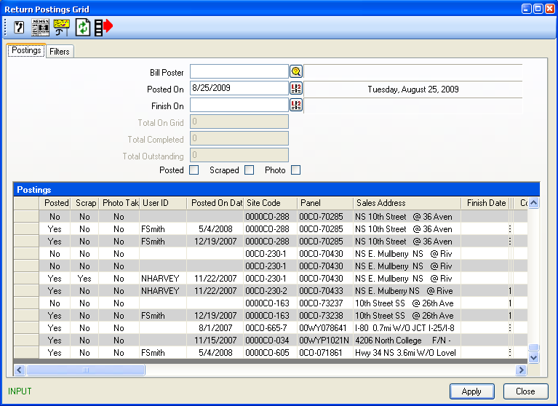

**Filters tab**

## 

There are various filters that can be used to display the panels to be posted.

|  |  |
| --- | --- |
| **Scheduled Designs From** | Enter a date range that the creative was Scheduled to Post. Defaults to current month. |
| **Assigned From** | Enter a date range that the Operations department had scheduled to Post. |
| **Campaign Start** | Enter a date range to view campaigns beginning during that time. |
| **Campaign End** | Enter a date range to view campaigns ending during that time. |
| **Campaign** | Enter the Campaign code or click the browse button to search for a campaign. |
| **Advertiser** | Enter the advertiser code or click the browse button to search. |
| **Agency** | Enter the agency code or click the browse button to search. |
| **Media Product Type** | To view schedulings for a specific media product type, enter the code or select the appropriate type from the browse list. |
| **Media Product** | To view schedulings for a specific media product, enter the code or select the appropriate type from the browse list. |
| **Billposter** | To view scheduled postings assigned to a specific billposter or rotary crew, select the appropriate name from the browse list. |
| **Sales Executive** | To view scheduled posting associated to a specific Sales Person. |
| **Include Completed Postings** | To include completed postings in the list, click this check-box “on” |
| **Include Assigned** | To exclude scheduling that has been assigned to a billposter or rotary crew, click this check-box “off”. Selected to display by default. |
| **Include Unassigned** | To exclude scheduling that have not been assigned to a billposter or rotary crew, click this check-box “off”. Selected to display by default. |
| **Include Offers** | To include scheduling for panels charted to campaign details in the offer stage (not ‘Sold’), click this check-box “on”. By default only sold contracts appear. |
| **Extra Panel Filter** | The Extra Panel filter can also be used to apply further filters. |

Once you have selected one or more filter criteria, click the Refresh  button to review your filtered scheduled inventory.

Select a billposter by either entering the code or using the browse window. Enter the post date in the Posted On field and select the posted checkmark to post all inventory on screen. *Please use this check box with care!*

To assign the post date to individual panels in the list, in the Posted column double-click on the word “No” in the row corresponding to the panel that has been posted. The Posted On Date will display as posted.

|  |  |
| --- | --- |
| **Billposter** | Select the Billposter who posted the design |
| **Posted On** | Enter the Date the design was posted |
| **Finish On** | If applicable, enter the date the design was taken down without being covered by another design |
| **Posted** | Check, to post all designs on the grid with the posting information entered above. Use with caution as this will post ALL records on the grid. |
| **Scraped** | Check, to add a scraped date to all panels on grid with the posting information above |
| **Photo** | Check, to note that a photo was taken of all postings on grid  ***Note:*** *Using the Post, Scrape or Photo check boxes cannot be undone.*  To post, mark scraped, or note a photo was taken for each panel individually, rather than all panels on the grid, double-click on the word “No” in the corresponding column/row for the panel.  Click Apply to save your changes. |
| **Total On Grid** | Displays number of inventory, posted and not posted reflected on the grid. |
| **Total Completed** | The total number of completed postings displayed on the grid |
| **Total Outstanding** | The total number of outstanding postings displayed on the grid |

Also available:

|  |  |
| --- | --- |
|  | **Booking History.** Displays the booking history of a panel. Highlight the panel and click the Panel History from the toolbar.  **Assign Designs.** Brings you to the Assign Designs window. Highlight the panel that belongs to the contract you would like to view designs for and click the Assign Designs button. You can now make changes to the Design assigned. |